Brian Martin QC: Meet the man who quit the NT youth detention royal commission
By Michael Coggan. Posted 28 July 2016, updated 1 August 2016
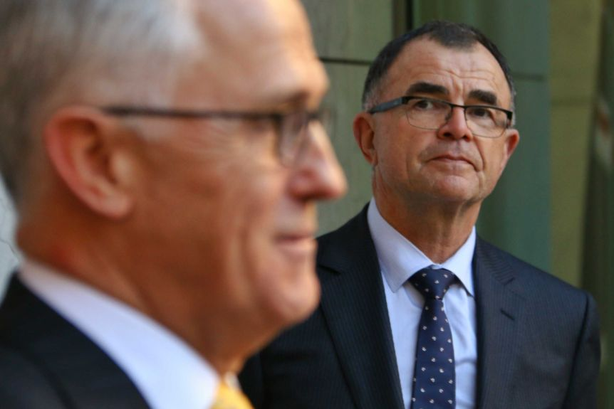
Above: Malcolm Turnbull PM appoints Chief Justice Brian Martin as Royal Commissioner into Youth Detention in the Northern Territory.

The man who had been chosen to head the royal commission into youth detention in the Northern Territory has stood down from the role after days of media scrutiny and claims of bias. Brian Martin QC has an intimate understanding of the legal landscape of the Top End and a long history of dealing with high-profile court cases. He was the chief justice of the Northern Territory Supreme Court between 2004 and 2010 after serving as a Supreme Court judge in South Australia.

As a young man growing up in the Adelaide Hills, he combined law studies with sport, playing football with SANFL club Sturt. His passion for football gave way to a legal career that saw him rise rapidly to crown prosecutor in Adelaide in the 1970s and Queen's Counsel status in 1984. He was Senior Counsel assisting the WA Inc Royal Commission in 1991. After three years as the Commonwealth director of public prosecutions, he was appointed a judge of the South Australian Supreme Court in 1999.
Justice Martin made his mark as a jurist capable of handling large challenging cases, presiding over the Snowtown "bodies in the barrels" murder trial and the Peter Falconio backpacker murder trial in the Northern Territory.

In 2005, a judgement in which he handed a 24-month jail sentence, suspended after four months, to a 55-year-old man who had sex with his 14-year-old "promised wife" and hit her with a boomerang attracted public criticism. In his sentencing remarks, Justice Martin had taken into account evidence that the actions were permitted under traditional Aboriginal law. He spoke about the complexities of dealing with cases involving traditional Aboriginal law when he spoke to the South Australian Press Club in 2006.

"We must not overlook the importance of traditional laws to many of these communities, not just in connection with crime and punishment, but in connection with the fundamental social structure of those communities," he said. Justice Martin also spoke about the development of criminal laws to deal with the rise of terrorism in the wake of the 2001 attack on New York's World Trade Centre.

Referencing the treatment at the time of South Australian David Hicks, he quoted Russian author Fyodor Dostoevsky: "A society should be judged not by how it treats its outstanding citizens, but by how it treats its prisoners." Answering questions from the media after his appointment as royal commissioner, Justice Martin was pressed on whether the role of race or racism would be examined.

Justice Martin is no stranger to cases where racism has been a factor. He presided over a manslaughter trial in Alice Springs where five men pleaded guilty to attacking and leaving Aboriginal man Kwementyaye Ryder to die in 2009.

The men, all in their 20s, received non-parole periods of between 12 months and four years.
In his judgement in 2010, he said the case had caused deep divisions in the Alice Springs community because of the view that it was racially motivated.

"It is difficult to avoid the conclusion that the nature and rapidity of the reaction, and the actions of some offenders in kicking and striking the deceased while he was on the ground were influenced, at least to some degree, by the fact that the deceased was an Aboriginal person," he said from the bench.

Despite the "cowardly and violent" assault, Justice Martin said it was impossible to know if the brain haemorrhage that caused Mr Ryder's death was caused by him hitting his head when he fell, or by the blows inflicted. He said Mr Ryder had a pre-existing aneurism, which could have burst at any time.
Justice Martin said every crime of manslaughter was serious, but the manslaughter of Mr Ryder was on the "lower end of the scale of seriousness" because none of the offenders were aware of the substantial risk of causing death.
'Unwarranted intrusion', claims of bias lead to resignation
Four days after he was appointed to undertake the royal commission into youth justice in the NT, Justice Martin contacted the Governor-General requesting he be removed from the role.

After his appointment was announced by Prime Minister Malcolm Turnbull, Indigenous groups raised concerns they were not consulted on the scope of the royal commission, and that it would not adequately understand the unique issues facing their communities.

Labor leader Bill Shorten called on for two Indigenous co-commissioners to also sit on the inquiry and some had raised concerns Justice Martin risked not being seen as impartial because of his former role in the NT justice system and his daughter's had previously worked for the Territory attorney-general.

In announcing his decision to resign he said he was "did not perceive, and still don't perceive, that there is any problem with bias, either actual or perception of bias, but others do. My resignation does not imply that I doubt my capacity to be both independent and competent in the role of the commissioner, nor does it imply that I accept that there is or would be a reasonable apprehension of bias," he said.

"I am not prepared to allow the unwarranted intrusion into the life of my daughter to continue. It has become apparent that, rightly or wrongly, in this role I would not have the full confidence of sections of the Indigenous community which has a vital interest in this inquiry."

